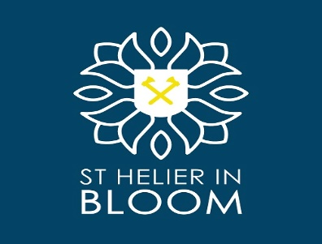

June 2023

Dear Supporter,

Thank you again for your continued support towards the floral displays in St Helier during 2022.

Not only do these displays bring life and colour to our town for both residents and visitors shopping experiences but have also helped in another successful year with St Helier competing in the finals of the National Britain in Bloom competition. We hope with your continued support we can again build upon our success in 2023.

If you have not supported the Parish floral displays previously your donation and support in 2023 would be very much appreciated.

- Hanging Baskets (£30.00 each)

-Window Boxes (£24.00 each)

- Hayracks (£30.00 each)

Total amount £

If you would like to review your previous allocation, your details have changed, or you have any questions please call 811708

FLORAL DISPLAY DONATION ADDRESS

Donation Amount of £ ……………………………………………………………………………

Traders Name: …………………………………………………………………………………….

PAYMENT METHODS

PLEASE QUOTE ON ALL PAYMENTS : BLOOM DONATION – 1046-006

DIRECT TO BANK: HSBC, Sort Code: 40-25-34, Account No. 91409816

CHEQUES PAYABLE TO - THE PARISH OF ST. HELIER, St Helier in Bloom, Municipal Services Depot, La Grande Route de St. Jean, St. Helier, JE2 3FN

CUSTOMER SERVICES – TOWN HALL

Please remember to send this remittance slip back with your donation payment to ensure your Company Name is included in our sponsorship publicity during 2023.

For more information about St. Helier in Bloom and other sponsorship opportunities
please contact our website on www.sthelier.je Tel 01534 811708 or email MunicipalServices@posh.gov.je

